10 Rental Tools for DIY Home Projects
by Fran J. Donegan for The Home Depot
If you don't own the right tools for tackling a remodeling or maintenance project, you have the option of renting them or buying them outright. The decision is usually based on how often the tool will be used and its cost. If you need something like a drill, it makes more sense to buy one because it is a good basic tool that will be used over and over. If the project is a one-time occurrence, such as installing large porcelain tiles, you may want to rent a large tile saw instead of buying one. Here are some other projects for when rental tools can help make the job a success.
Interior Projects
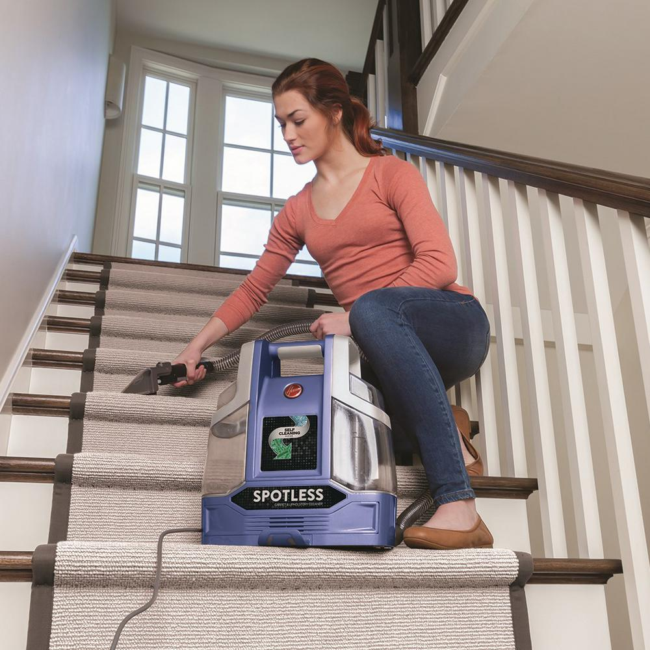
Refinishing wood floors. While a solid wood floor can last for many years, the floor's finish will wear out and require refinishing. A drum sander is the best tool for removing the old finish. If you have never used one, ask the rental agent to show you how it works. Before you start, make sure there are no nail heads protruding above the surface of the floor. Also, keep in mind that drum sanders are bulky tools that cannot remove the floor's finish close to the wall or in tight spaces, such as closets. For those areas, you will need a smaller, handheld edge sander. You’ll also need sandpaper, purchased separately, for both tools.
Carpet cleaning. For most jobs, you can rent a light-duty carpet cleaner. But for tough jobs, there are commercial-grade carpet extractors available. Both require special cleaning solutions, so be sure to ask about that at the rental outlet. To speed up the drying process, rent a carpet blower fan at the same time.
Painting projects. Painting rooms with high ceilings usually means spending a lot of time climbing up and down ladders. While roller extensions can help, another option is to rent a scaffold for interior work. You can adjust the height of the scaffold to your needs. Some are narrow enough to easily roll through a 30-inch door opening. If the project calls for removing old wallpaper, rent a professional-grade wallpaper steamer. They are messy to use, but if you prepare for the dripping water, they provide the quickest way to strip a wall of old paper.
Unclogging drainpipes. For stoppages that you would usually call a drain cleaning service for, such as one caused by tree roots in the main drain line, consider an auto-feed drain snake, which automatically advances and retrieves the cable. It's much easier to use than older manual tools. Many types have enclosed drums that cut down on the mess, but cleaning out a drainpipe is dirty work, so protect the surrounding area. Place the tool as close as possible to the opening, and wear heavy work gloves when operating the machine.
Exterior Projects
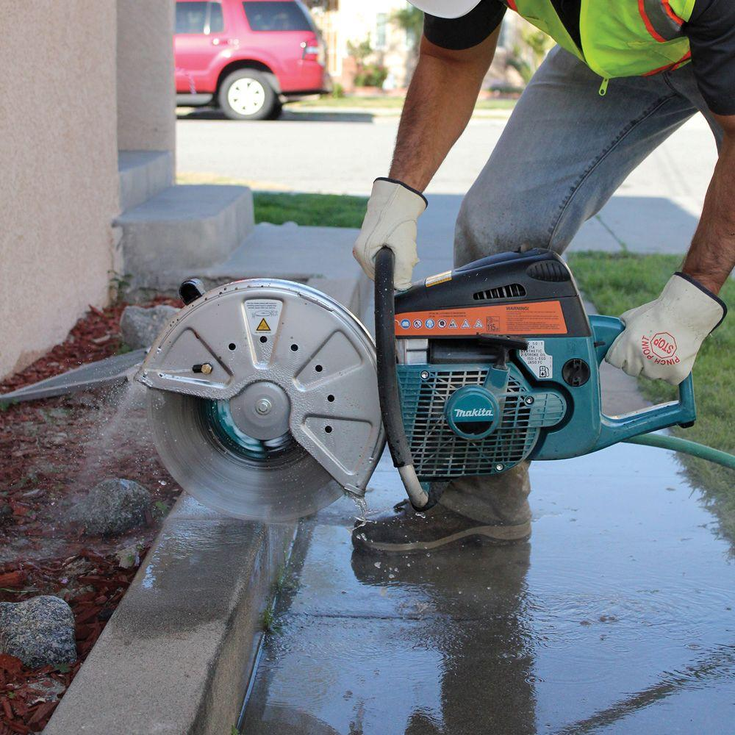
Digging post holes. There are inexpensive handheld clamshell post-hole diggers available for purchase, but think of all the holes you will need to fence in your yard. Power augers make the job go much faster, plus they’re easier on your back. They are available in one- and two-person models. The auger bits come in a variety of sizes, so you can find one to dig the right diameter holes you need. When operating the auger, periodically stop the machine and lift it out of the hole to clear the hole of dirt.
Also, before starting any work, be sure to call 811, which connects you to your local "Call Before You Dig" Program. When you make the call, a specialist will come to your home to mark the locations of underground utility lines so that you avoid running into one while digging.
Cutting masonry. Whether you need to saw through a concrete slab or cut concrete block, brick or other masonry material to size, use a gas-powered concrete saw. Discuss the project with the rental agent to make sure you get the right blade. To bust up an old patio, use a demolition hammer or the more powerful breaker hammer. Be sure to wear safety shoes and eye and ear protection when operating cutting equipment.
Pouring concrete. You can mix concrete by hand, but using a barrel concrete mixer is faster and usually provides better results. Many mixers work on electricity and are attached to a moveable cart. If you're using bagged concrete mix, be sure to follow the manufacturer's directions for mixing and adding water. QUIKRETE®, a manufacturer of concrete products, suggests adding half of the required water first, followed by the concrete mix. Let the mixer work for a minute or two and then add the rest of the water as needed. Mixing usually takes about five minutes total.
Gardening and Landscaping Projects
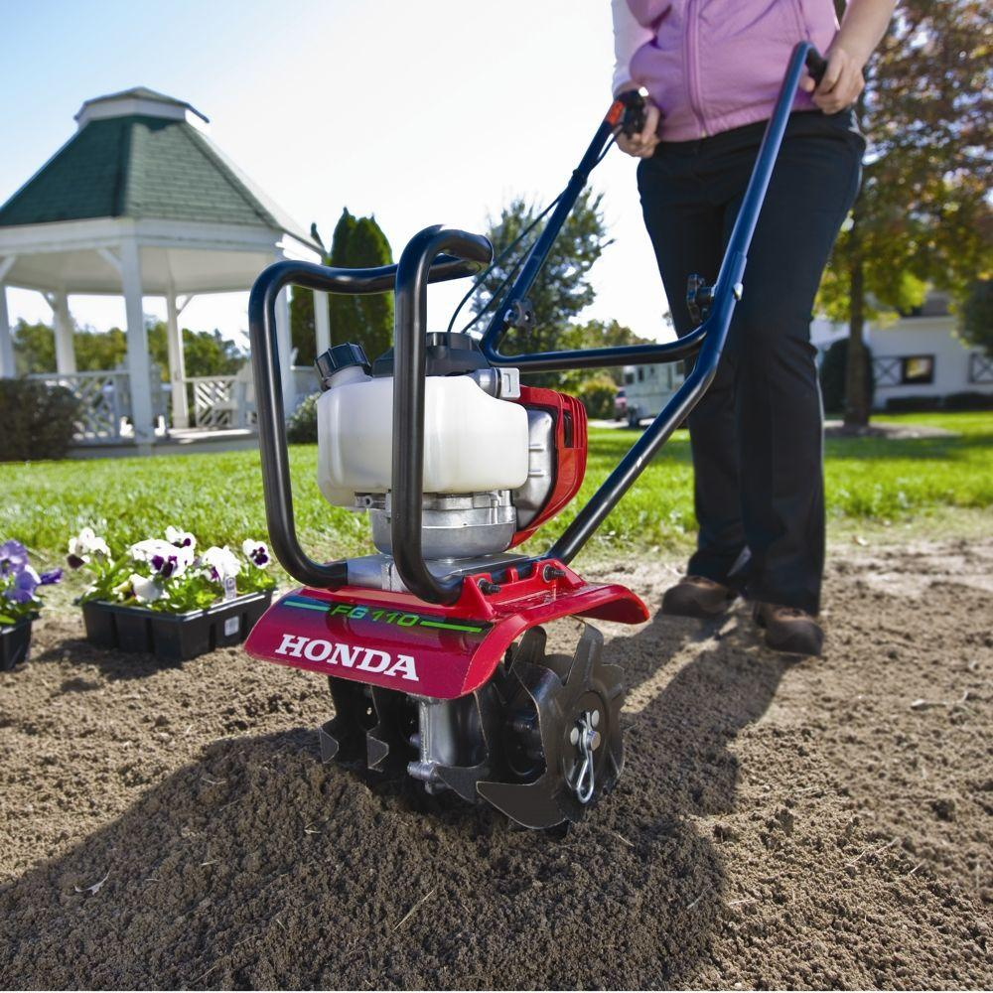
Preparing soil for a garden. A gas-powered tiller, sometimes called a rototiller, makes short work of breaking up soil for planting. Rear-tine tillers usually provide the most tilling power and are good choices for soil that has never been tilled, as opposed to mid-tine and front-tine models. Those with counter-rotating tines do a good job on heavy clay soils. If the garden has already been tilled and you want to work compost or some other soil amendment into the garden, a lighter-weight front- or mid-tine model will do the job.
Removing trees. Whether you want to cut down a tree or cut up a tree that is already on the ground, a chainsaw is the tool to use. If you have never used one, go over safety basics and techniques with someone who has experience with the tool before going to work. Safety is the prime concern when using a chainsaw. Wear steel-toe shoes, a chainsaw helmet with a face shield, ear protection, and special chainsaw chaps.
Other Projects
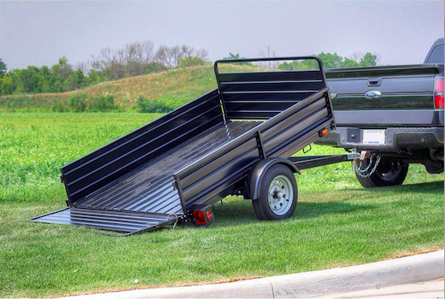
Moving. You can rent all types of hand trucks and dollies for moving furniture and appliances around the house. You can also rent trailers for getting building materials or other heavy loads home. If you plan on renting a trailer, you will need to make sure that the tow vehicle has the capacity to tow the load, as well as a proper lighting hookup so that the trailer lights will work. Be sure that the ball and hitch assembly on your tow vehicle matches the coupler on the trailer.
Whether you decide to rent tools or buy them, it’s important to use the right tool for the job because it will help provide the best results.
###
Fran Donegan writes home- and garden-related content for numerous digital and print publications. He is the author of the books "Pools and Spas" and "Paint Your Home." To learn more about tools available for rent like those referenced in this article, please visit The Home Depot website.

